LAB ASSIGNMENT-5



NAME: M Gyanada Chowdary

REG.NO: 21bce7727

COURSE: Computer Networks

SLOT: L21+22

Task:

Create 2 vlan's and make communication between them by using inter-vlan routing.

Step1:

Take 4 Pcs and a Switch and connect them using Copper Straight

Through Cable.

PC1, PC2 = VLAN 1

PC3, PC4= VLAN 2

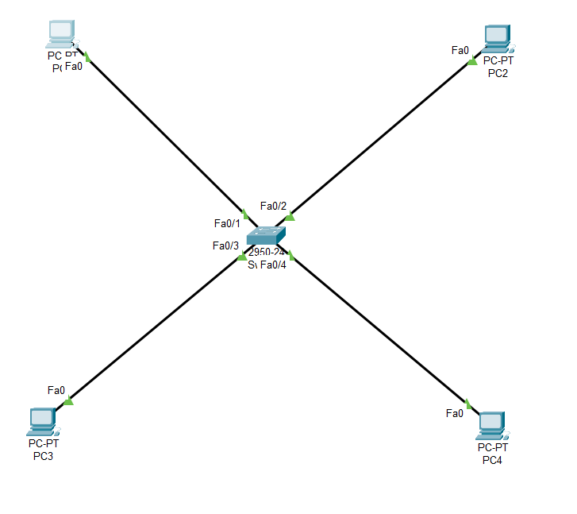

Step 2:

Give IP configurations to the PC’s and connect the switch to a router.

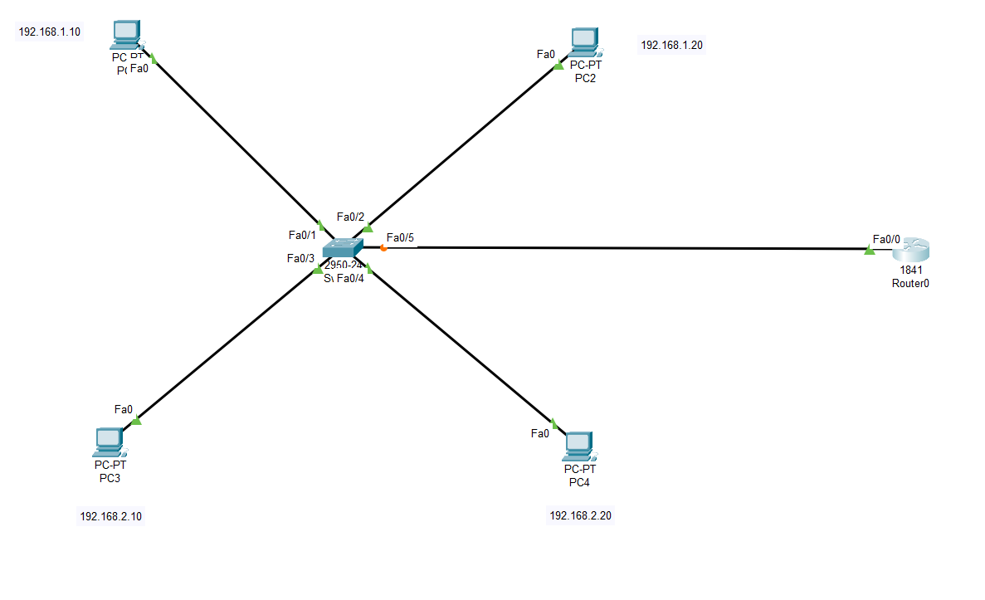

Step 3:

Go to Switch and Go to CLI to give access to VLAN.

Using these commands

SwitchCLI mode –

For VLAN 1:

Show VLAN brief

Switch> enable

Switch # configure terminal

Swith(config) # VLAN 10

Switch(config - VLAN) # name vit

Switch(Config - VLAN) # port

Int Fa0/1

Switchport mode access

Switchport access VLAN 10

Switch port mode trunk

-------------------------------------------------

For VLAN 2:

Show VLAN brief

Switch> enable

Switch # configure terminal

Swith(config) # VLAN 20

Switch(config - VLAN) # name ap

Switch(Config - VLAN) # port

Int Fa0/3

Switchport mode access

Switchport access VLAN 20

Switch port mode trunk

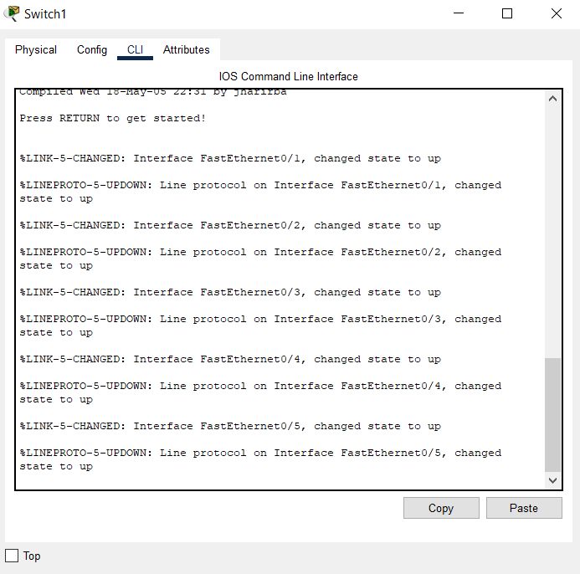

Step 4:

Take a Simple PDU and check if it’s working.

Steps:

1)

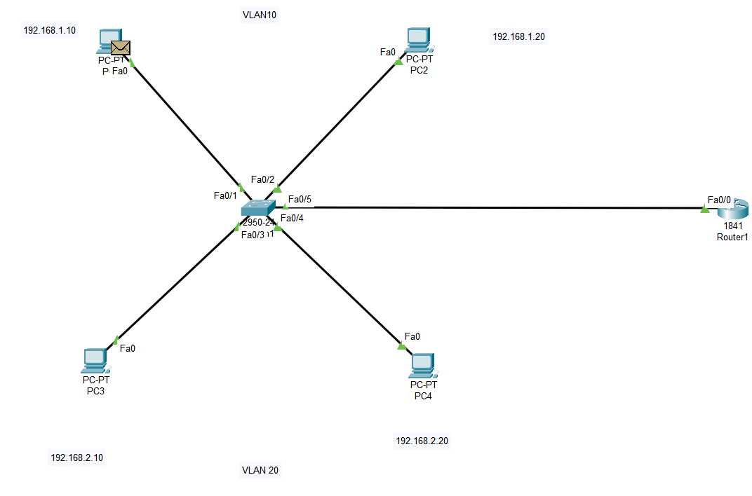

2)

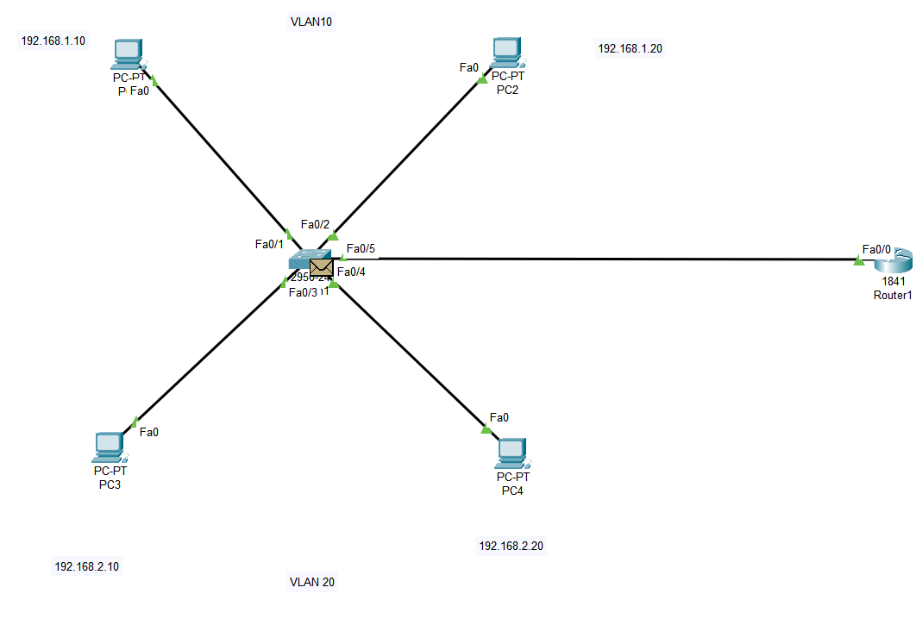

3)

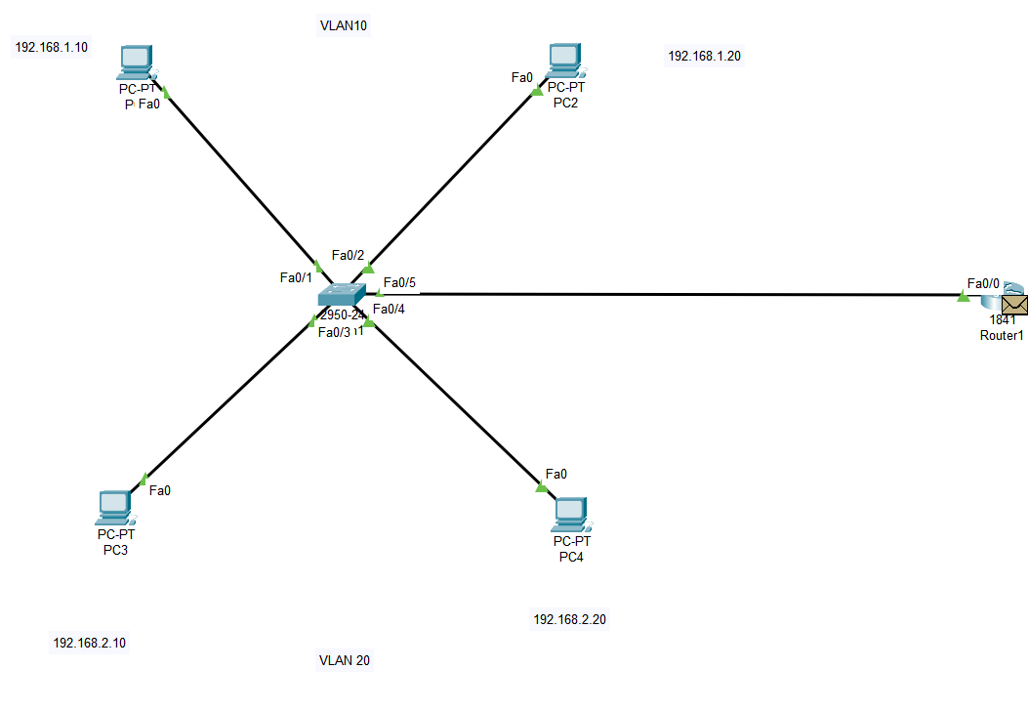

4)

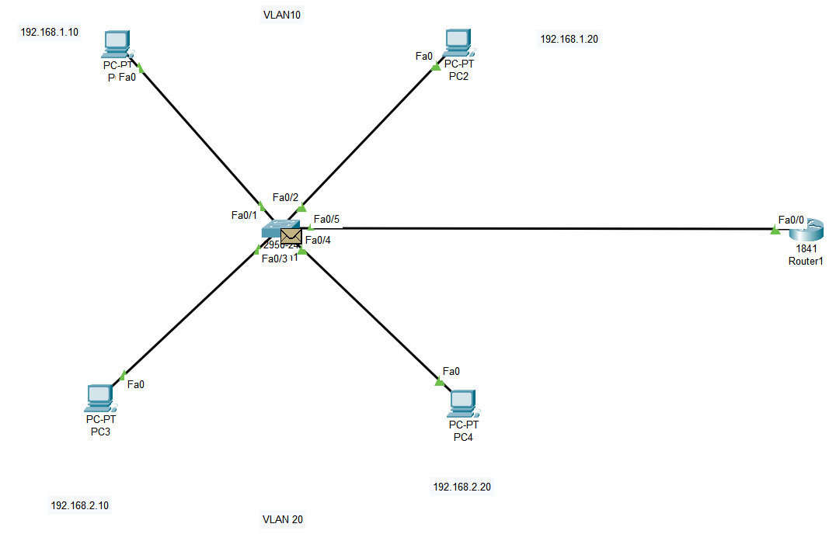

5)

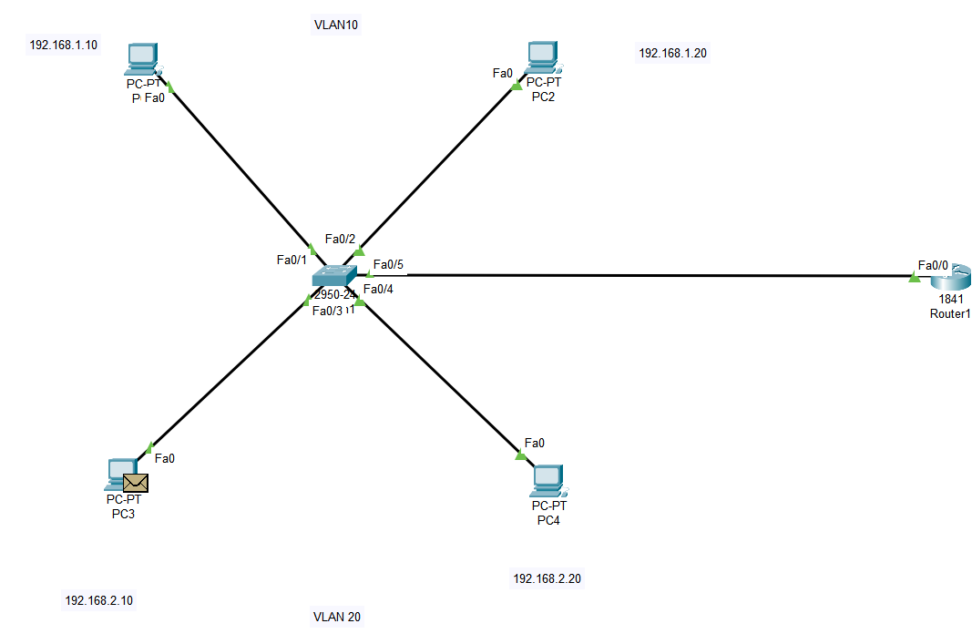

6)

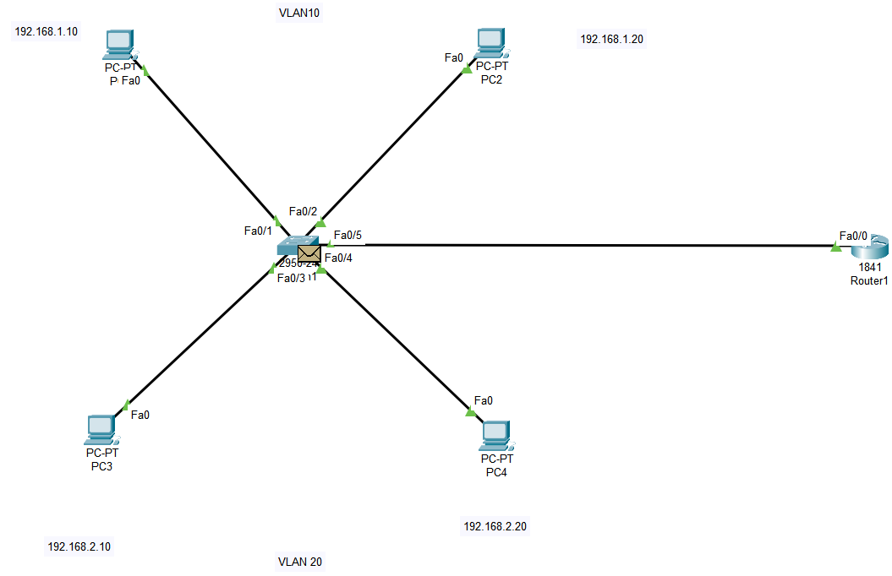

7)

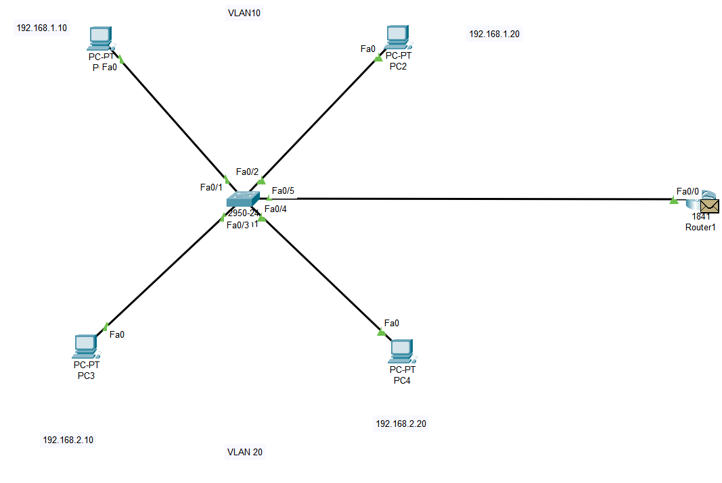

8)

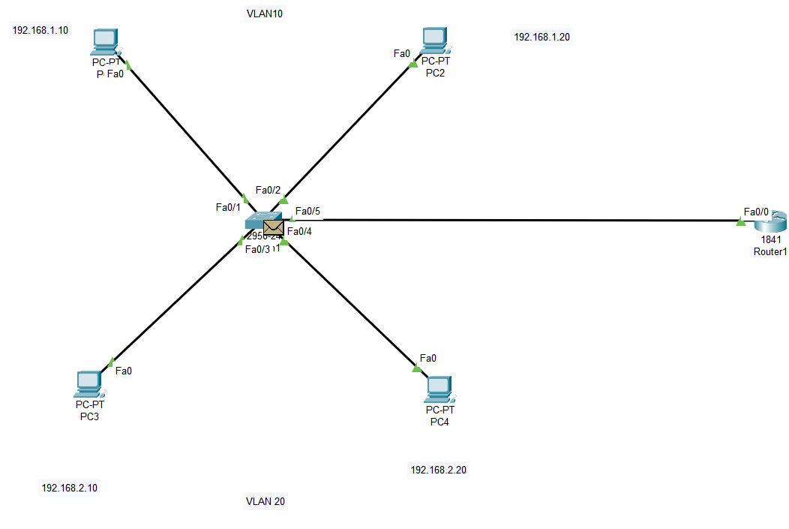

9)

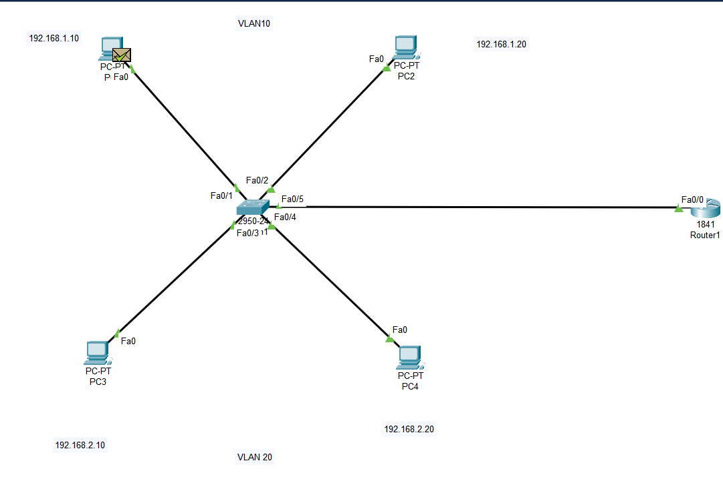

FINAL OUTPUT:

